
DecoVibe

Metal Wall Art Category

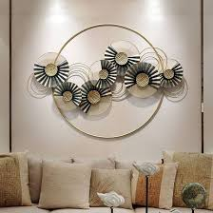
This elegant contemporary wall sculpture is designed to enhance modern interiors with its stylish and artistic structure.
Made from durable materials with a smooth premium finish, it offers both strength and beauty.

Its unique shape and balanced design make it a perfect centerpiece for feature walls.
A great choice for homeowners who want to elevate their décor with a luxury touch.

